
Registration to become a Member of the Forum is quite easy. Just click on the Link “Register” provided at the top left corner of the RSCWS Forums Page (See Figure 1). The Registration Page (See Figure 2) will open and you have to just fill out the requisite information and submit the Registration. You’ll receive an Email for confirmation, and then the Membership will become activated! In case of any problem, feel free to contact Site Administrator Email: navtejpvs@gmail.com
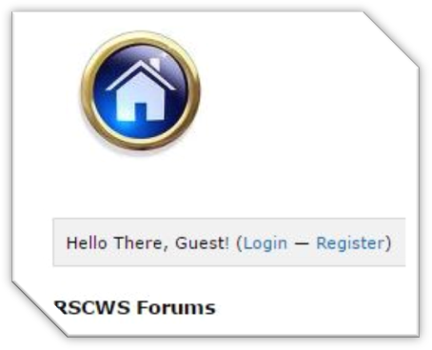
Figure 1
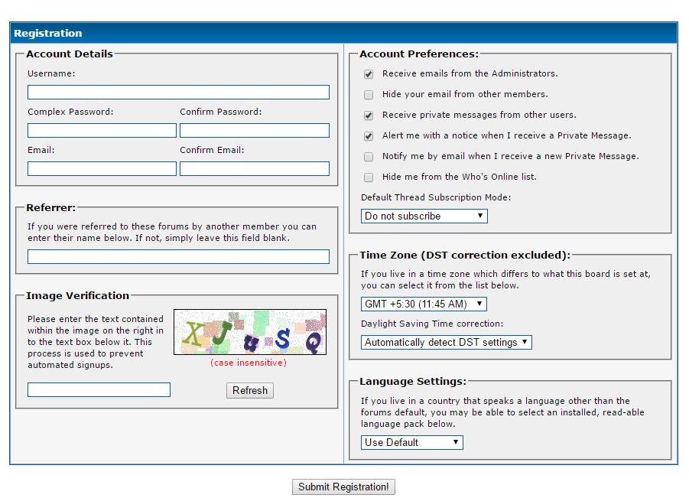
Figure 2

